Experience Norway - From Mountains to Fjords
Wednesday July 31st Airport pick-up  Drive to Nesbyen. Assignment of cabins.  Grilling/BBQ for the evening  Accommodation Bjørnerud Mountain Farm  Thursday August 1st Bjørnerud Mountain Farm.  Get to know each other. Prepare equipment for mountain hike.  A short trip to test equipment.  Friday 2nd Mountain tour.  Mountain hike to Sletthallin (about 5 hrs)  Set up lavo tent, Cook dinner over a fire, sleep in lavo.  Saturday 3rd Mountain tour.  Hike to Langedrag Wildlife Park  See 30 species of wildlife including wolves.  Sunday 4th Visit Nesbyen.  Guided tour in Gardnosbeksja  Visit Hallingdal Folk Museum.  Visit Trytetjern for swimming and volleyball.  Monday 5th Train trip to Myrdal - Flåm  Bergensbanen train to Myrdal  Flåmsbanen down the mountain to Flåm  Ål Rotary Club meets at Flåm for local sightseeing.  Dinner in Flåm. Private transport back to Ål.  Accommodation TopCamp Hallingdal.  Tuesday 6th Visit Ål  Høyt & Lavt Hallingdal Climbing Park  Pizza will be served at Hesla farm for dinner.  Accommodation Hesla Farm, Gol  Wednesday 7th Visit Gol  Pers Hotel Tropicana / Bowling  Kjersti`s food and wine house for lunch  Narum Farm serves traditional local food for dinner.  Accommodation Hesla Farm.  Thursday 8th Visit Oslo  Transport to Oslo - Sightseeing  Accommodation Haraldsheimen  Friday August 9th Departure  Airport train to Gardermoen airport | 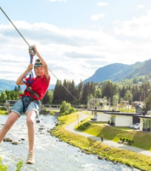  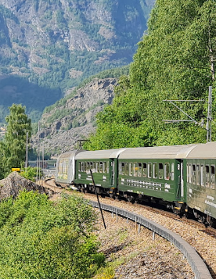  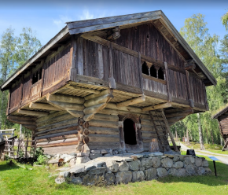  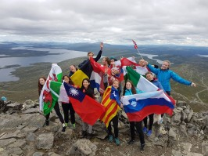

Experience Norway - From Mountains to Fjords
Necessary Clothing and Equipment
Shorts and swimwear. Solid hiking shoes. Small rucksack. Water bottle.
Water-wind-proof jacket. Warm outer clothing. Fleece, sweater, and hat.

Costs:
Participation Fee: EUR 500.
Airfares and spending money.
Insurance as per Rotary International requirements for youth exchange program.
Other costs are covered by D2310 and host clubs.

Applications:
Applications will be considered in order of being received.
Please download and complete your application form electronically.
Print the result. Apply the necessary handwritten signatures and scan the result to pdf. Send completed application to step.inbound@rotary.no

Participants:
10 students, 5 girls and 5 boys aged 17 to 20. Max 2 from same country.

Rotary Hosting Clubs
This Rotary Summer Camp is supported by passionate Rotarians who have dedicated their time and energy to provide you with the opportunity to experience the best of Central and Eastern Norway. The primary contact person for each of the participating clubs is listed below.

Buskerud Mountain Region:
Nesbyen Rotary Club: Thomas Øye
Gol Rotary Club: Aud Ingunn Narum
Ål Rotary Club: Tore Arnegard

Oslo The Capital:
Oslo International Rotary Club: Irena Tenase

